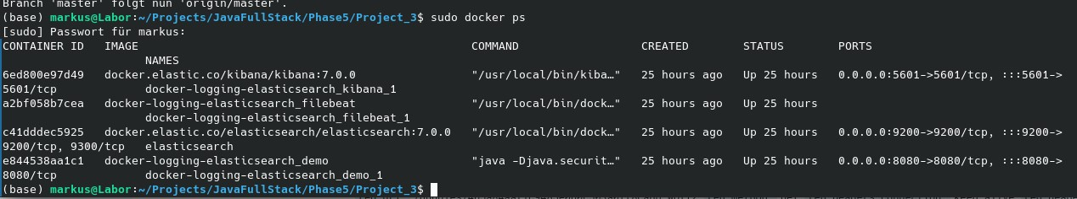

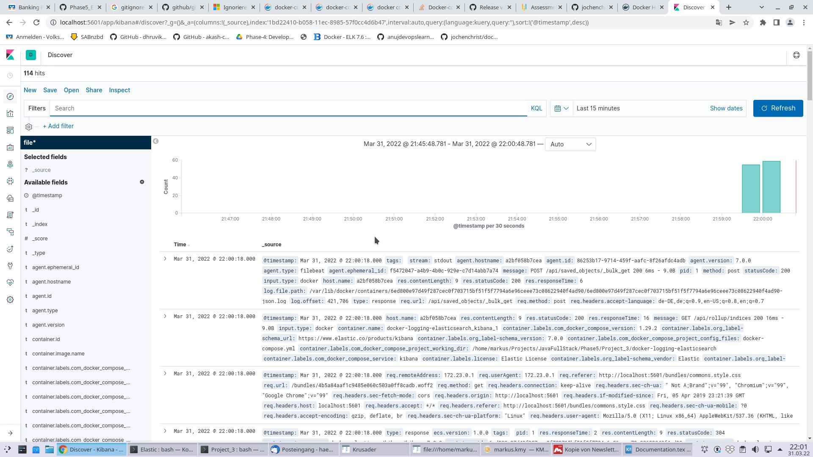

Continuous Monitoring on Docker with ELK Stack

Used Technologies:

Kibana

ElasticSearch

Filebeat

Docker

